WAIVER OF LIABILITY
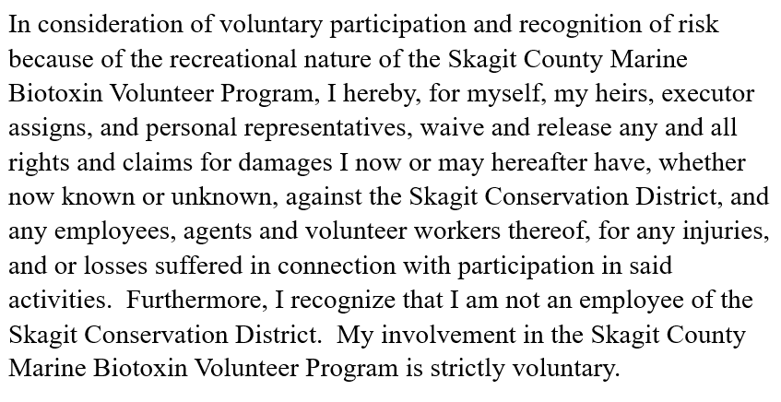
PLEASE PRINT (Skagit County Marine Biotoxin Volunteer)

NAME: ________________________________________________________________

ADDRESS: _____________________________________________________________

PHONE: __________________________ EMAIL: ____________________________

SIGNATURE: _________________________________________________________________
DATE OF SIGNATURE: ________________________________________________________

Return to: Carla Glassman
Skagit Conservation District
2021 E. College Way, Suite #203
Mount Vernon, WA 98273

